Attendees:
- Bob
- Shannon
- Tim
Configuration - Shannon R to add rejection reasons to existing groups in Configuration.
WIP REJ Report – Update column
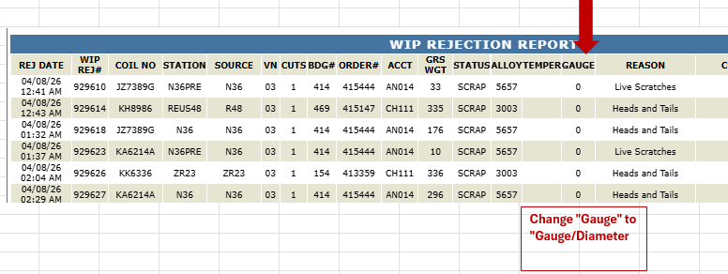

WIP LOG – Add FL1, FL2, FL3 to “Station” drop down menu
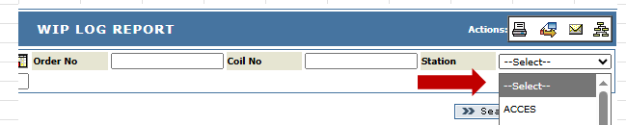
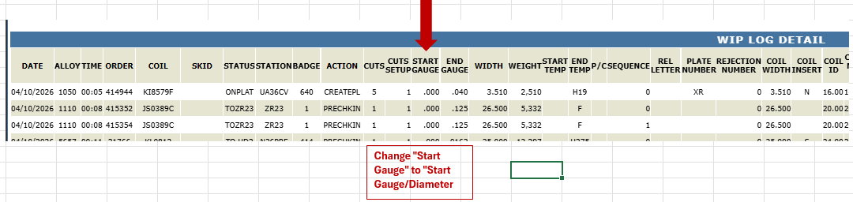
  - Process would like a hyperlink added in WIREJ log that links directly to Mill Reports (Gauge Trace) like the SCADA hyperlink.
    - 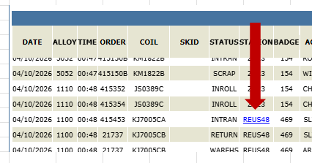
Scada Report – UA will need to create chart layout and determine what machine tags will be created and what columns will be necessary.
  - Need to read the tags from the machine
Flat Wire - Need to add Flattening Lines tab (new menu link under .Net Reports) as a copy of Slitter Reports tab. This new report should show 3 machines listed, same as slitters report. Clicking on any of them will take to the report shown below. (Gauge trace) (Gauge CPK Deviation Report)( Gauge CPK Report ).
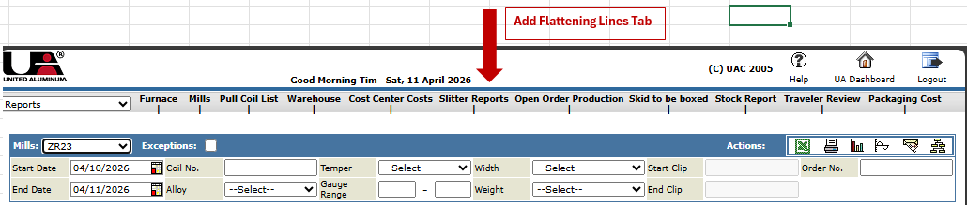

Flattening Lines report layout adaptation: (change Gauge to Gauge/Diameter and remove # Cuts column).
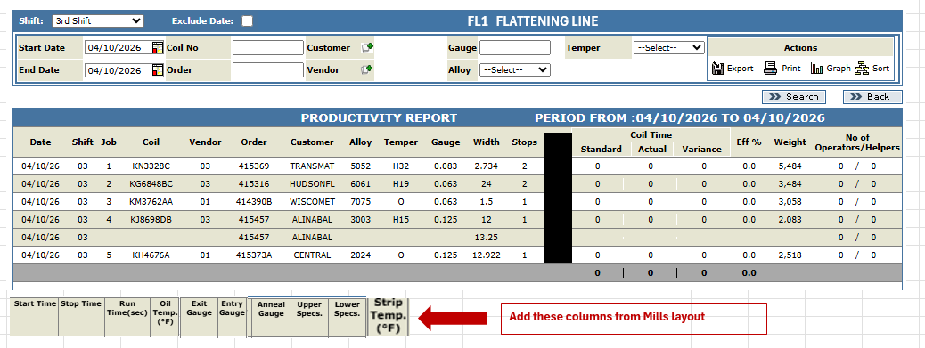
Coil Pass Detail – will need to be copied form Mills and then modified for correct attributes. UA to create a template for this.

Gauge CPK Report - Need to add dropdown Strip/Flat Wire/All.
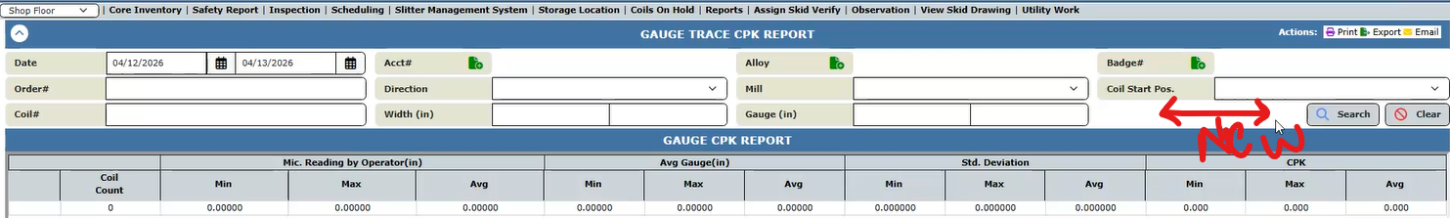

Cut Traceability Report - Terminology to dictate where alpha is in the spool, ID/OD/MID. “Cut#” columns are not required for flat wire.
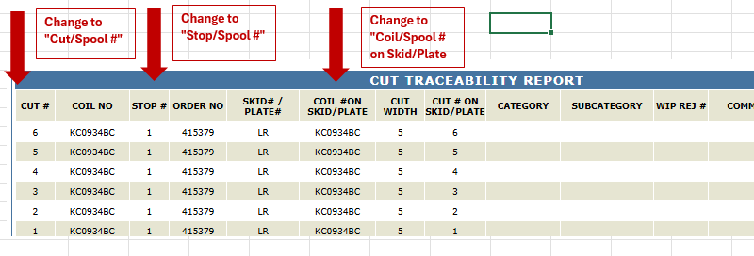

Rolls in Flattening Report: Make a copy of the “Rolls In Mill Report” and make the below mentioned changes.
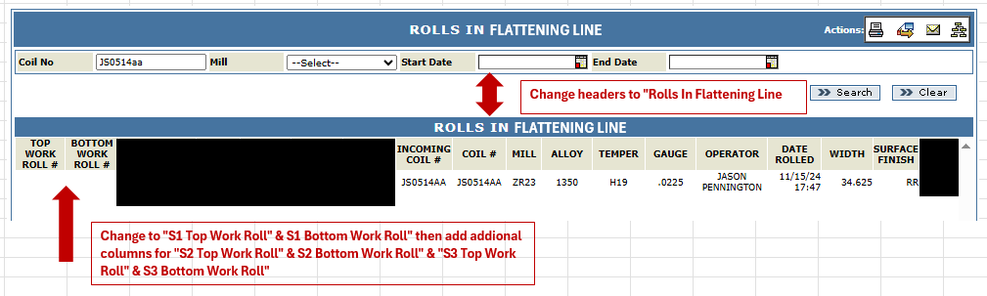
Rolls Qualification Sheet – not certain is needed for this application

SPC at Mill report & Slitter Coil Report Adaptation - Using Gauge at Mill, create a new report for SPC at Flattening Line. Add FL1, FL2, FL3 to dropdown menu.
